**Secure Coding**

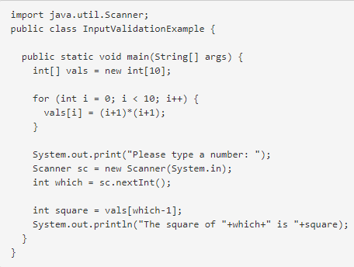

If the user inputs a non-integer value. In Java, this causes a NumberFormatException to be thrown. If the user enters a value that does not lie between 0 and 9. In Java, this will lead to an ArrayIndexOutOfBoundsException. A robust program would catch this error, provide a clear and appropriate error message, and ask the user to re-type their input.

**Inheritance -** using the structure and behavior of a super class in a subclass.

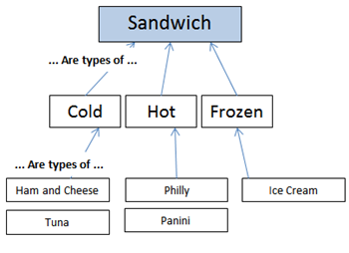

**Polymorphism -** changing the behavior of a super class in the subclass.

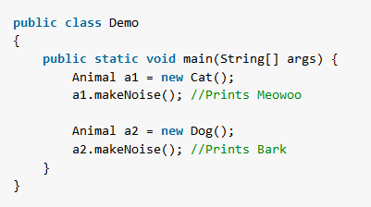

**Encapsulation** - Hiding and/or restricting access to certain parts of a system, while exposing the necessary interfaces.

**Abstraction** - Considering something with certain characteristics removed, apart from concrete realities, specific objects, or actual instances, thereby reducing complexity.

**File Reading**

BufferedReader inFile = null;

PrintWriter outFile = null;

try

{

inFile = new BufferedReader(new FileReader("poem.txt"));

outFile = new PrintWriter(new FileWriter("poemOutput3.txt"));

String readData System.out.println ("---OUTPUT FILE BEING PRODUCED---\n");

while ((readData = inFile.readLine()) != null)

{ outFile.println(readData);

System.out.println("Line of output: " + readData); } }

finally

{

System.out.println("Open poemOutput3.txt\n\n");

if (inFile != null) {

inFile.close();

if (outFile != null) {

outFile.close(); }}